SEC Form 3
FORM 3 | UNITED STATES SECURITIES AND EXCHANGE COMMISSION  Washington, D.C. 20549  INITIAL STATEMENT OF BENEFICIAL OWNERSHIP OF SECURITIES  Filed pursuant to Section 16(a) of the Securities Exchange Act of 1934  or Section 30(h) of the Investment Company Act of 1940
  OMB APPROVAL
  OMB Number: | 3235-0104
  Estimated average burden
  hours per response: | 0.5
1. Name and Address of Reporting Person*  (Street) | 2. Date of Event Requiring Statement (Month/Day/Year)  08/12/2026 | 3. Issuer Name and Ticker or Trading Symbol  Bicara Therapeutics Inc. [ BCAX ]  Foreign Trading Symbol
  Larson Jennifer
  (Last) | (First) | (Middle)
  BICARA THERAPEUTICS INC.
  116 HUNTINGTON AVENUE, SUITE 703
  BOSTON | MA | 02116
  (City) | (State) | (Zip)
 |  | 4. Relationship of Reporting Person(s) to Issuer  (Check all applicable) | 5. If Amendment, Date of Original Filed (Month/Day/Year)
   | Director |  | 10% Owner
   | Officer (give title below) |  | Other (specify below)
  Chief Financial Officer
6. Individual or Joint/Group Filing (Check Applicable Line)
Form filed by One Reporting Person
Form filed by More than One Reporting Person

Table I - Non-Derivative Securities Beneficially Owned
1. Title of Security (Instr. 4) | 2. Amount of Securities Beneficially Owned (Instr. 4) | 3. Ownership Form: Direct (D) or Indirect (I) (Instr. 5) | 4. Nature of Indirect Beneficial Ownership (Instr. 5)
Table II - Derivative Securities Beneficially Owned
(e.g., puts, calls, warrants, options, convertible securities)
1. Title of Derivative Security (Instr. 4) | 2. Date Exercisable and Expiration Date (Month/Day/Year) |  | 3. Title and Amount of Securities Underlying Derivative Security (Instr. 4) |  | 4. Conversion or Exercise Price of Derivative Security | 5. Ownership Form: Direct (D) or Indirect (I) (Instr. 5) | 6. Nature of Indirect Beneficial Ownership (Instr. 5)
1. Title of Derivative Security (Instr. 4) | Date Exercisable | Expiration Date | Title | Amount or Number of Shares | 4. Conversion or Exercise Price of Derivative Security | 5. Ownership Form: Direct (D) or Indirect (I) (Instr. 5) | 6. Nature of Indirect Beneficial Ownership (Instr. 5)
Explanation of Responses:
Remarks:
Exhibit 24 - Power of Attorney
No securities are beneficially owned.
 | /s/ Ryan Cohlhepp, Attorney-in-Fact | 08/14/2026
 | ** Signature of Reporting Person | Date
Reminder: Report on a separate line for each class of securities beneficially owned directly or indirectly.
* If the form is filed by more than one reporting person, see Instruction 5 (b)(v).
** Intentional misstatements or omissions of facts constitute Federal Criminal Violations See 18 U.S.C. 1001 and 15 U.S.C. 78ff(a).
Note: File three copies of this Form, one of which must be manually signed. If space is insufficient, see Instruction 6 for procedure.
Persons who respond to the collection of information contained in this form are not required to respond unless the form displays a currently valid OMB Number.
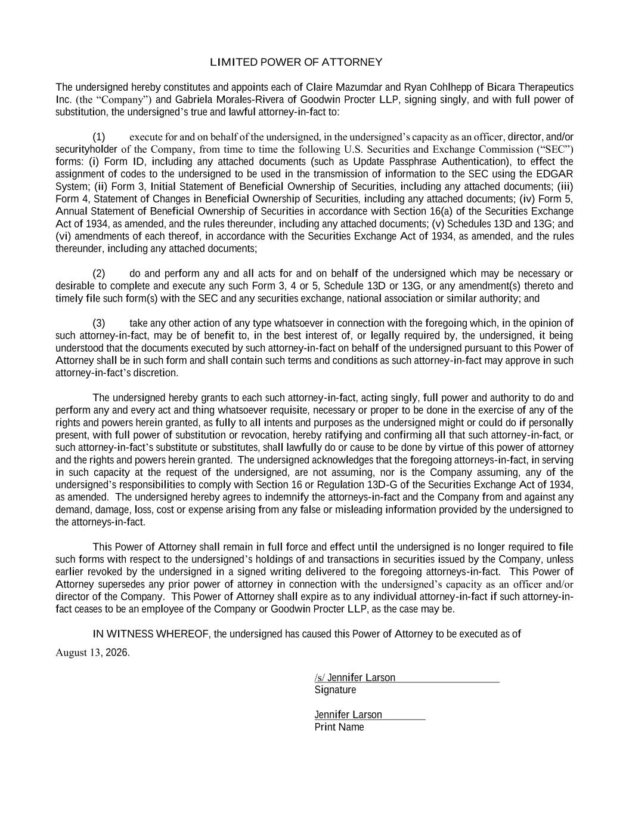
LIMITED POWER OF ATTORNEY The undersigned hereby constitutes and appoints each of Claire Mazumdar and Ryan Cohlhepp of Bicara Therapeutics Inc. (the “Company”) and Gabriela Morales-Rivera of Goodwin Procter LLP, signing singly, and with full power of substitution, the undersigned’s true and lawful attorney-in-fact to: (1) execute for and on behalf of the undersigned, in the undersigned’s capacity as an officer, director, and/or securityholder of the Company, from time to time the following U.S. Securities and Exchange Commission (“SEC”) forms: (i) Form ID, including any attached documents (such as Update Passphrase Authentication), to effect the assignment of codes to the undersigned to be used in the transmission of information to the SEC using the EDGAR System; (ii) Form 3, Initial Statement of Beneficial Ownership of Securities, including any attached documents; (iii) Form 4, Statement of Changes in Beneficial Ownership of Securities, including any attached documents; (iv) Form 5, Annual Statement of Beneficial Ownership of Securities in accordance with Section 16(a) of the Securities Exchange Act of 1934, as amended, and the rules thereunder, including any attached documents; (v) Schedules 13D and 13G; and (vi) amendments of each thereof, in accordance with the Securities Exchange Act of 1934, as amended, and the rules thereunder, including any attached documents; (2) do and perform any and all acts for and on behalf of the undersigned which may be necessary or desirable to complete and execute any such Form 3, 4 or 5, Schedule 13D or 13G, or any amendment(s) thereto and timely file such form(s) with the SEC and any securities exchange, national association or similar authority; and (3) take any other action of any type whatsoever in connection with the foregoing which, in the opinion of such attorney-in-fact, may be of benefit to, in the best interest of, or legally required by, the undersigned, it being understood that the documents executed by such attorney-in-fact on behalf of the undersigned pursuant to this Power of Attorney shall be in such form and shall contain such terms and conditions as such attorney-in-fact may approve in such attorney-in-fact’s discretion. The undersigned hereby grants to each such attorney-in-fact, acting singly, full power and authority to do and perform any and every act and thing whatsoever requisite, necessary or proper to be done in the exercise of any of the rights and powers herein granted, as fully to all intents and purposes as the undersigned might or could do if personally present, with full power of substitution or revocation, hereby ratifying and confirming all that such attorney-in-fact, or such attorney-in-fact’s substitute or substitutes, shall lawfully do or cause to be done by virtue of this power of attorney and the rights and powers herein granted. The undersigned acknowledges that the foregoing attorneys-in-fact, in serving in such capacity at the request of the undersigned, are not assuming, nor is the Company assuming, any of the undersigned’s responsibilities to comply with Section 16 or Regulation 13D-G of the Securities Exchange Act of 1934, as amended. The undersigned hereby agrees to indemnify the attorneys-in-fact and the Company from and against any demand, damage, loss, cost or expense arising from any false or misleading information provided by the undersigned to the attorneys-in-fact. This Power of Attorney shall remain in full force and effect until the undersigned is no longer required to file such forms with respect to the undersigned’s holdings of and transactions in securities issued by the Company, unless earlier revoked by the undersigned in a signed writing delivered to the foregoing attorneys-in-fact. This Power of Attorney supersedes any prior power of attorney in connection with the undersigned’s capacity as an officer and/or director of the Company. This Power of Attorney shall expire as to any individual attorney-in-fact if such attorney-in- fact ceases to be an employee of the Company or Goodwin Procter LLP, as the case may be. IN WITNESS WHEREOF, the undersigned has caused this Power of Attorney to be executed as of August 13, 2026. Signature Jennifer Larson Print Name /s/ Jennifer Larson

